Chapter 5
- Maximum Coins – Greedy Approach
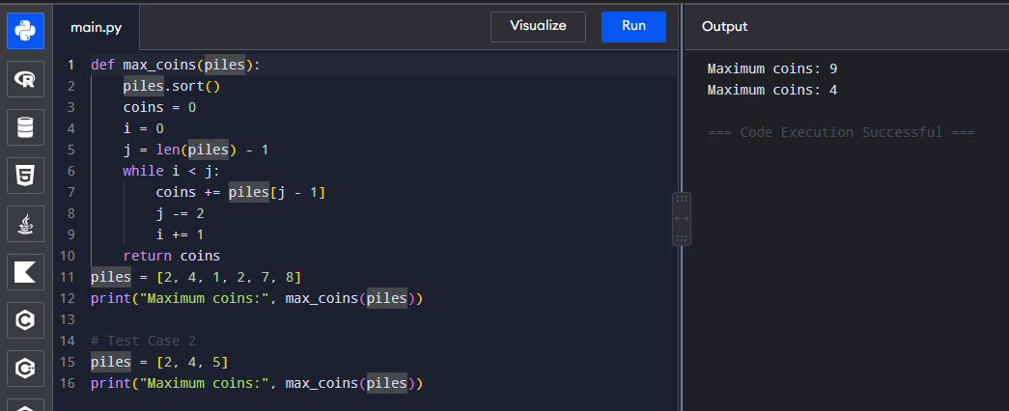
- Minimum Number of Coins to Add
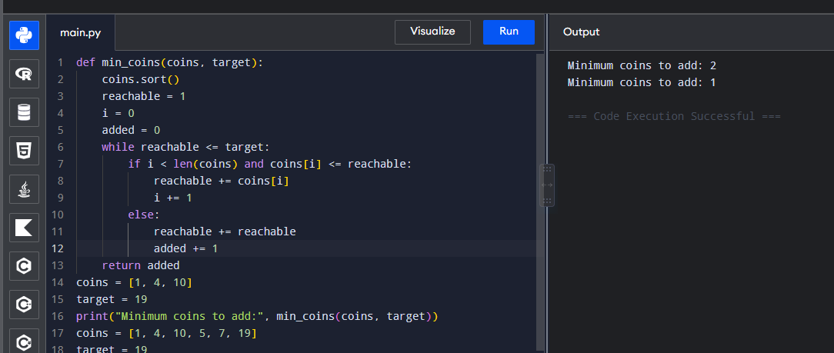
- Minimum Maximum Working Time of Workers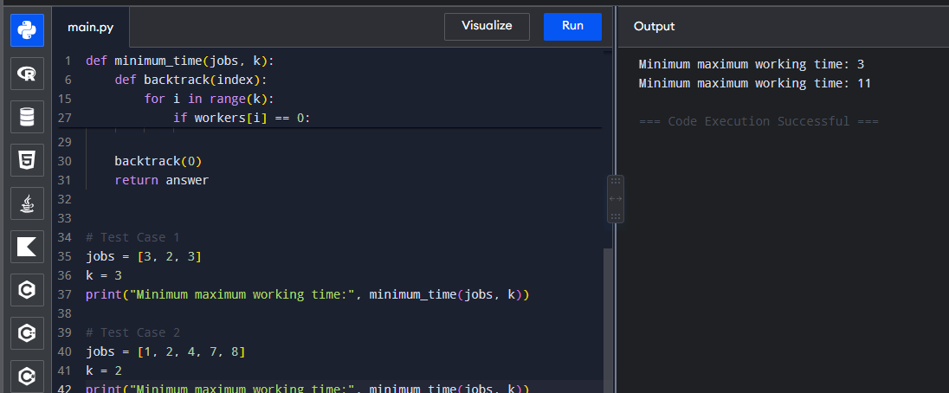
- Maximum Profit from Non-Overlapping Jobs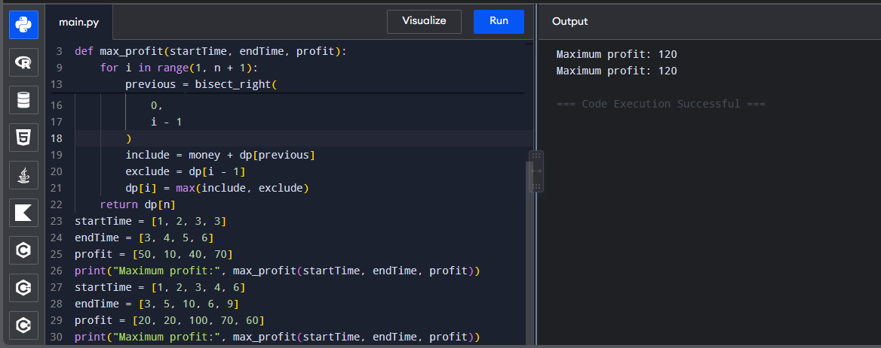
- Dijkstra's Algorithm – Adjacency Matrix
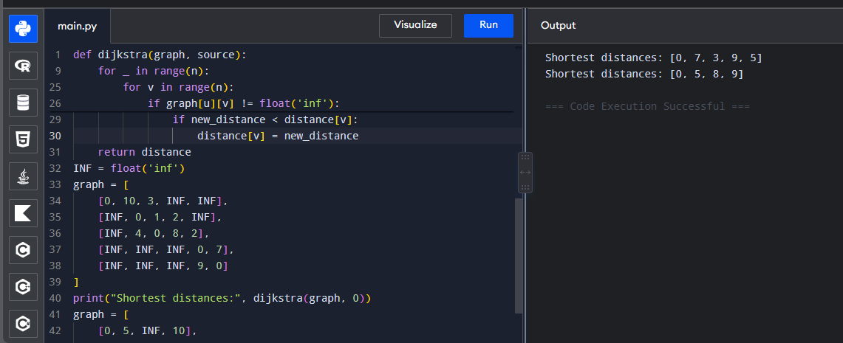
- Dijkstra's Algorithm – Edge List
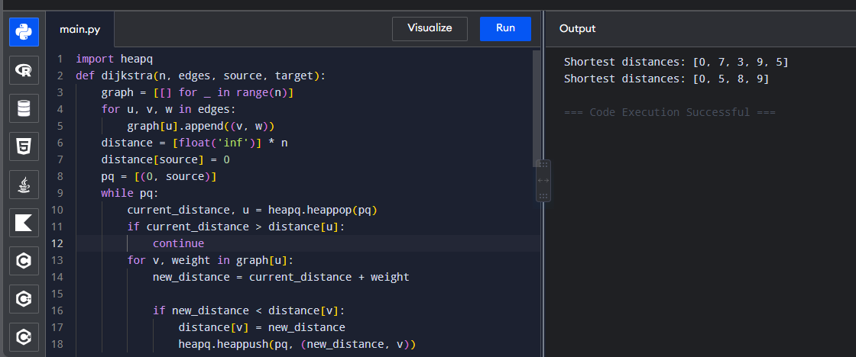
- Huffman Tree – Generate Huffman Codes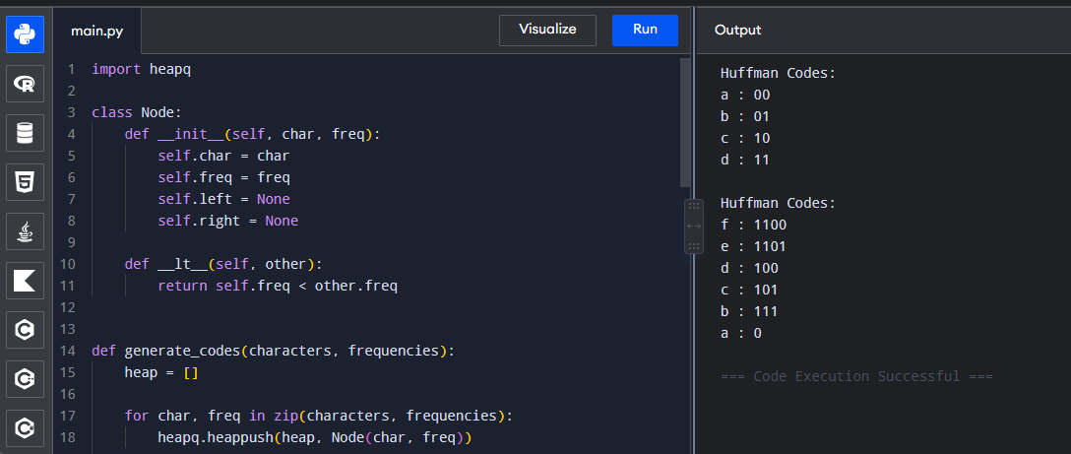
- Huffman Decoding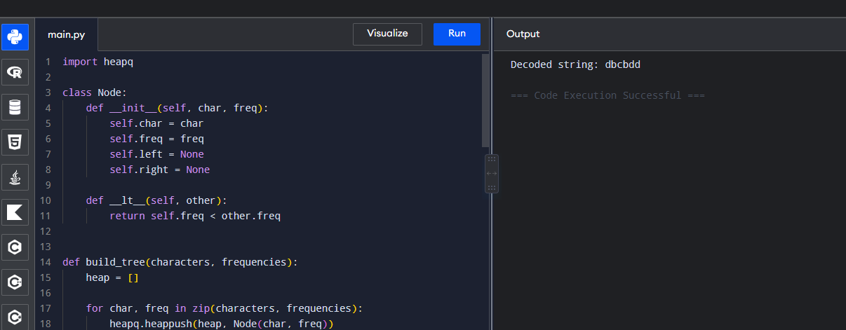
- Maximum Weight Using Greedy Approach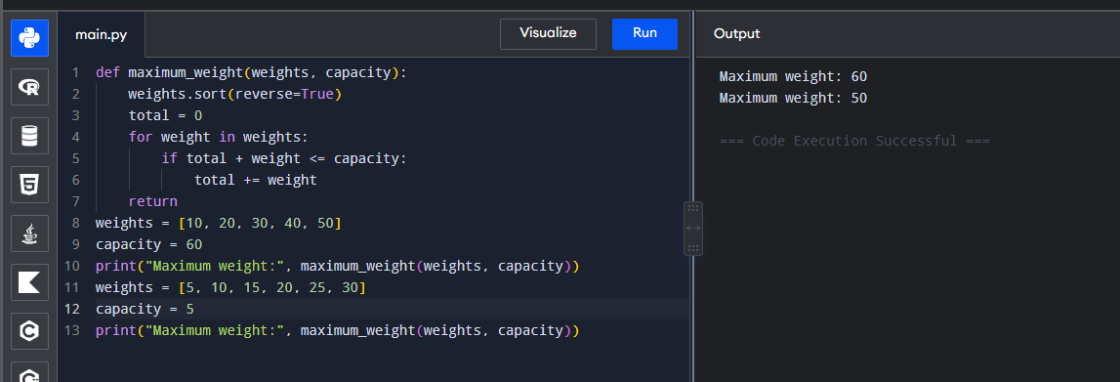

- Minimum Number of Containers – Greedy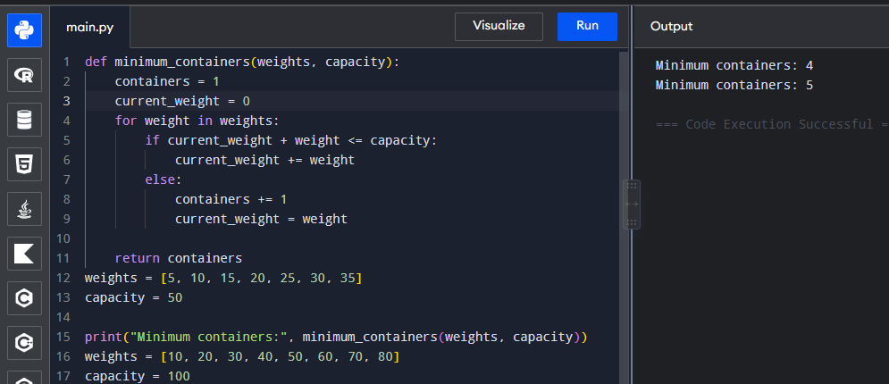
- Kruskal's Algorithm – Minimum Spanning Tree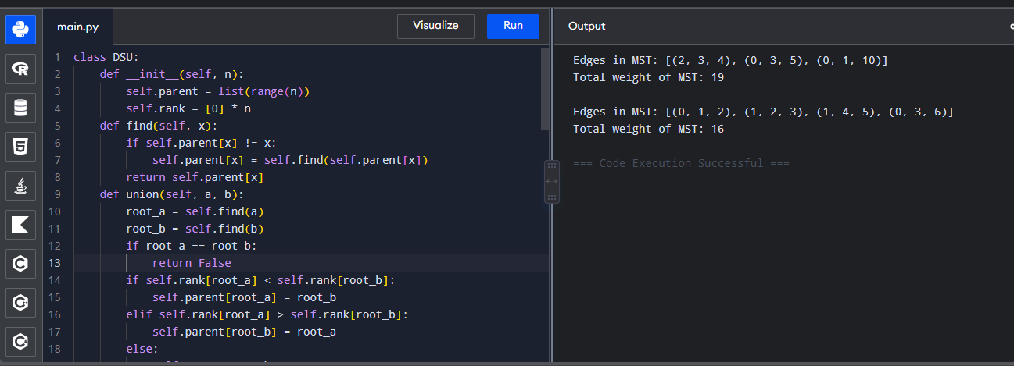
- Check Whether MST is Unique
